
Zewail City of Science, Technology and Innovation
Communications and Information Engineering Program
CIE 239: Digital Logic and Computer Architecture

ALU PROJECT

Prepared & Presented By:

Mohammed Soliman 202402280
Omar Elshaar 202402030
- Selection Logic:
The user of the program will have the ability to select the aimed operation he wants by entering the input “S” with the code of the input operation as shown:

S3 | S2 | S1 | S0 | Function (F)
0 | 0 | 0 | 0 | Add
0 | 0 | 0 | 1 | Subtract (B – A)
0 | 0 | 1 | 1 | 2's complement (A' + 1)
1 | 1 | x | x | Only GT, LT, EQ Flags
1 | 0 | 0 | 0 | A AND B
1 | 0 | 0 | 1 | A XOR B
1 | 0 | 1 | 0 | A OR B
1 | 0 | 1 | 1 | B' (1's Complement)
1 | 1 | 0 | 0 | Logical Shift Left
1 | 1 | 0 | 1 | Logical Shift Right

- Working Logic:
The program works as a single block with smart selection from the very beginning which guarantees better power consumption and avoids unwanted or meaningless results.

- Using Guidance:
User of this program should input his 3’bit two inputs A, B which and select his operation code as illustrated making sure that operations done on only A or B may use the other one as it’s reference like in shifting logic Unit the operation is done on “A” while the first 2’bit of B is using to determine the shifting amount aimed for the operation.
- Structural Diagram:
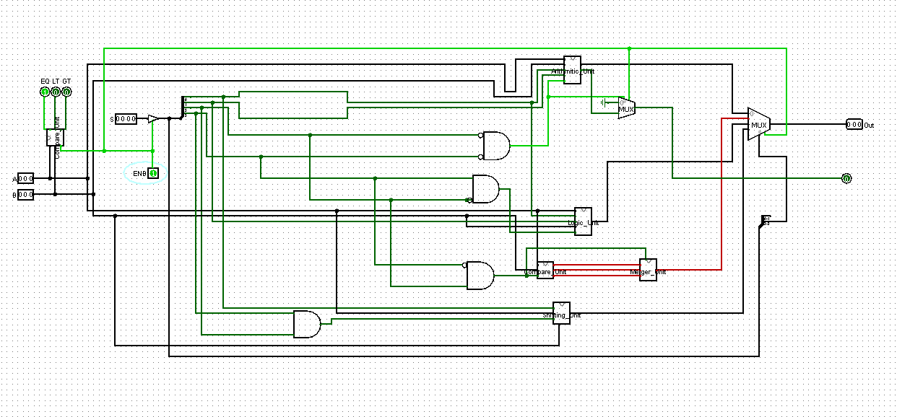
Designed using: Logicsim-win-2.7.1

- Descriptive Code Properties:
The Code of the signal simulation of the program is designed using the appropriate range of bits and operats based on the minimized range using vectors propertes. The code compines many different styles includes structural, functional, behavioral and always block codings. All the the cases are tested using built in test bench.
- Modular Diagram:
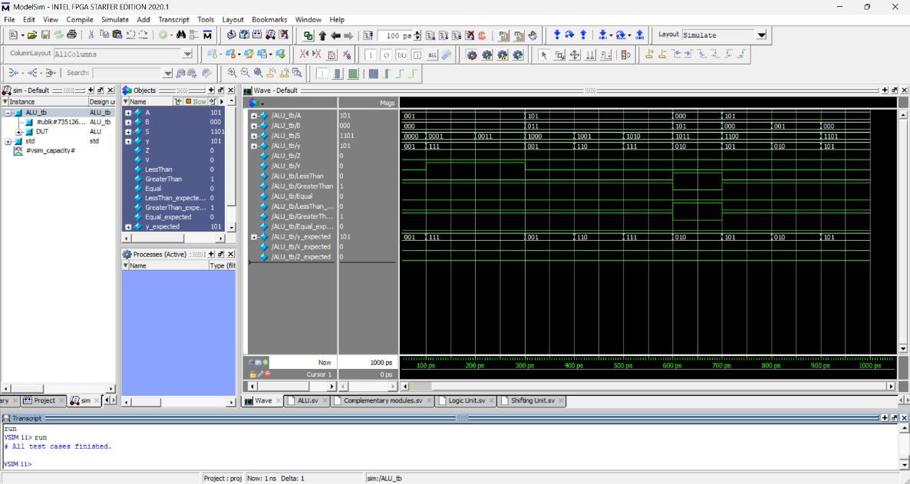
Designed using: ModelSim-win-20.1.1

